Ste. Rose School
Kindergarten School Supply List
2023-2024

▪ Paint Shirt
▪ Runners (non- marking soles for gym floor)
▪ Sleep Mat (Small bath towels)
▪ School Bag
▪ Lunch Kit
▪ Kleenex Box
▪ 1 set head phones (for computer use) – no earbuds please
▪ $45.00 – to cover costs of all other supplies (if paying by cheque make payable to Ste. Rose School no later than Friday,
September 15, 2023)

Please be sure to send all the supplies (with student’s name labeled on the items) on the first day.

Thank you for your co-operation.

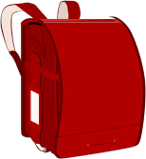
Ste. Rose School
Sayla Ogg

