Ste. Rose School
2023-2024

Grade 5 Supply List
- pencil case
- pencils (6)
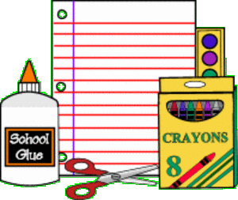
- blue pens (4)
- red pens (2)
- pencil crayons
- erasers (2)
- glue stick
- ruler
- 5” scissors
- highlighter marker(1)
- basic calculator
- homework folder
- 2-inch binders (4)
- duotangs (1)
- looseleaf paper (2 packets)
- gym clothes (t-shirt, shorts or sweat pants)
- indoor runners (non-marking soles for gym floor)
- box of Kleenex
- Headphones or ear buds
- ***backpacks are suggested for daily use!
See you in September!
Thank you,
Mr. Timlick – Grade 5 Teacher

